COMMUNITY PRESBYTERIAN CHURCH

505 West Broadway

Plainview, MN 55964

Sunday, April 14, 2024

Second Sunday after Easter

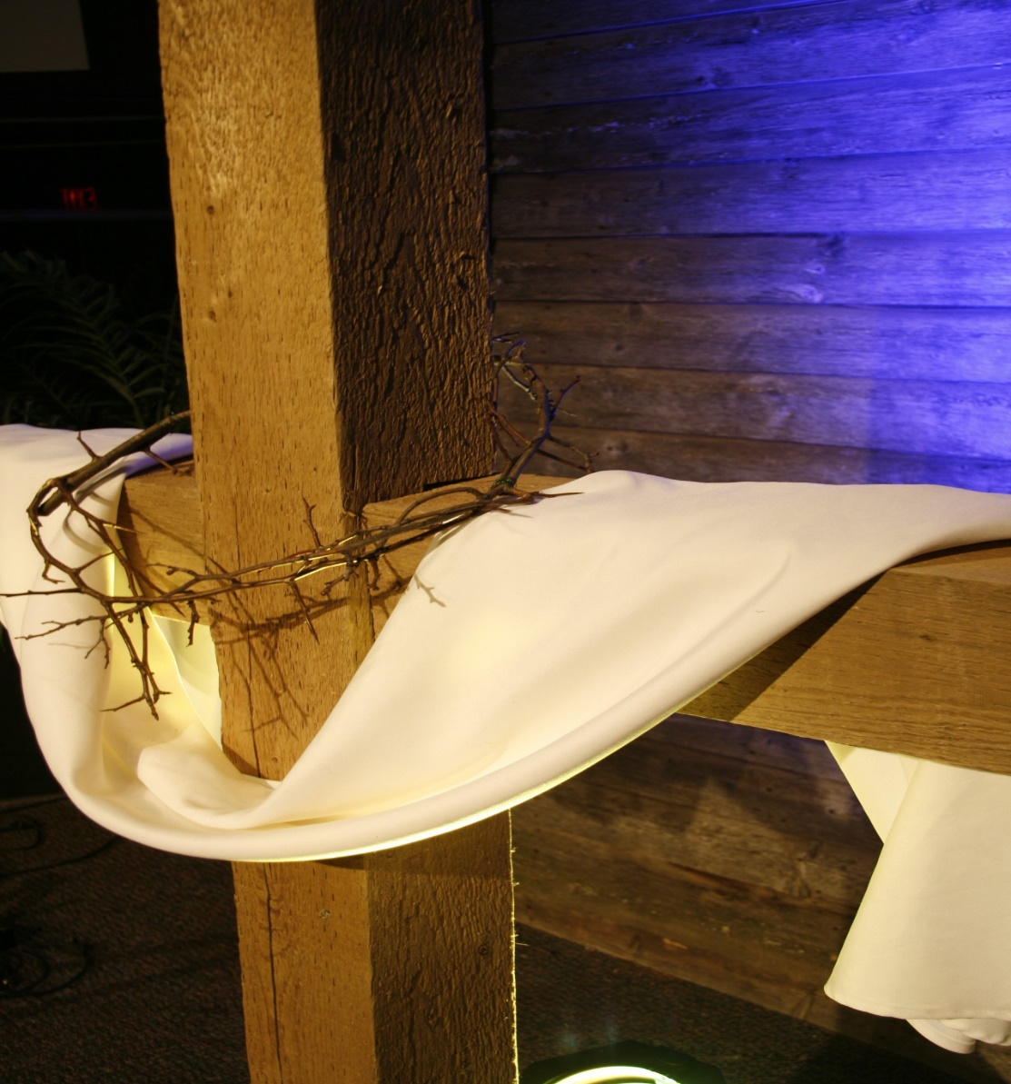

Welcome to Community Presbyterian Church!

Page 1*Please stand if you like
*Please stand if you like.
Page 2 *Please stand if you like
Sunday, April 14, 2024

Page 1*Please stand if you like
*Please stand if you like.
Page 2 *Please stand if you like

Page 1*Please stand if you like
*Please stand if you like.
Page 2 *Please stand if you like

Second Sunday after Easter

Gathering
PRELUDE Joan Lee, Organ

WORDS OF WELCOME

ANNOUNCEMENTS

CALL TO WORSHIP Diane Ellringer
Come to worship Jesus Christ, risen forever.
Come to rejoice in life born out of death.
Come to grasp hope in the face of fear.
Come to find forgiveness for your sins.
Come to release your burdens into the very presence of God.
Alleluia! Alleluia! Alleluia!
Let us worship God!

PRAYER OF PRAISE AND ADORATION Diane Ellringer
Let us pray together:
Holy and Living God, like a tomb’s darkness that gives way to light, open us this day to newness of life; open us to your love, to your acceptance, to your forgiveness, to your peace; open us to one another, and to the possibilities you have in store for us. Give us hope for the future and a passion for life here and now. We pray in the name of the One who destroyed death, Jesus Christ, our Savior. Amen.

OPENING HYMN #630 “Fairest Lord Jesus”

CALL TO CONFESSION Diane Ellringer
As we prepare to come to the table with the risen Jesus today, we continue to be witnesses to the resurrection!
Let us forsake all that holds us back from this joy as we offer our confession.

PRAYER OF CONFESSION Diane Ellringer
Let us pray together:
Gracious and loving God, the resurrection of your Son has not pulled us far from our old ways. Our faith becomes fear in the face of the world’s troubles. We trust more in the power of “the way things are” than in the new life you grant. We hesitate to speak out against wrong, convinced it will do no good. We excuse ourselves from chances to help others, fearing for our security. We stay busy with small concerns to avoid facing our shortcomings. Holy God, forgive our fears and our doubts. Plant Easter seeds in us to push through the packed, dead ground of old habits. Transform our suffering into greater faithfulness. Catch us up into the dance of your Holy Spirit, so that we may find hope and strength for the living of these days. Amen.

INDIVIDUAL CONFESSION
ASSURANCE OF PARDON Pastor Denise Dunbar-Perkins
One: Friends, even the hardest and most unchanging rock gives way to the persistent dripping of water. In the same way, God’s continual grace washes away our failings and shapes us into faithful disciples of Christ. By the waters of baptism, God forgives us all our sins. Let go of the old ways. Live new lives of confident faith, abundant hope and overflowing love.
All: Thanks be to God! Alleluia!
GLORY TO GOD #581 “Gloria Patri” “Glory Be to the Father”

SHARING GOD’S LOVE Pastor Denise Dunbar-Perkins

The Word
PRAYER FOR ILLUMINATION Diane Ellringer
Let us pray together:
Risen One, with Mary Magdalene, help us recognize you this day as we hear your word and feast together. You are “Rabboni,” our Teacher, our Guide. Come speak to us, that we might be messengers of your love and doers of your word. Amen.
THE EPISTLE LESSON Diane Ellringer
Acts 5: 27-35, 38-42

THE GOSPEL LESSON Pastor Denise Dunbar-Perkins
John 20: 11-18
MESSAGE “MARY MAGDALENE TOLD IT ALL” Pastor Denise Dunbar-Perkins

Responding
HYMN #238 “Thine Is the Glory”

AFFIRMATION OF FAITH (The Apostle’s Creed)
I believe in God, the Father almighty, Maker of heaven and earth;
And in Jesus Christ his only Son, our Lord; who was conceived by the Holy Ghost, born of the Virgin Mary, suffered under Pontius Pilate, was crucified, dead, and buried; he descended into hell; the third day he rose again from the dead; he ascended into heaven, and sitteth on the right hand of God the Father Almighty; from thence he shall come to judge the quick and the dead.
I believe in the Holy Ghost; the holy catholic church; the communion of saints; the forgiveness of sins; the resurrection of the body; and the life everlasting. Amen.

CALL TO PRAYER #441 “Hear the Good News of Salvation” (Verse 1)

JOYS AND CONCERNS Pastor Denise Dunbar-Perkins

PRAYERS OF THE PEOPLE AND THE LORD’S PRAYER
Our Father, who art in heaven, hallowed be Thy name. Thy kingdom come, Thy will be done, on earth as it is in heaven. Give us this day our daily bread and forgive us our debts as we forgive our debtors. And lead us not into temptation but deliver us from evil, for Thine is the Kingdom and the Power and the Glory forever. Amen.
INVITATION TO THE LORD’S TABLE Pastor Denise Dunbar-Perkins

GREAT PRAYER OF THANKSGIVING
The Lord be with you.
And also with you.
Lift up your hearts.
We lift them to the Lord.
Let us give thanks to the Lord our God.
It is right to give our thanks and praise.
…And so, we raise our voices in praise:
Holy, Holy, Holy Lord, God of power and might, heaven and earth are full of your glory. Hosanna in the highest. Blessed is he who comes in the name of the Lord. Hosanna in the highest.
We raise our voices to proclaim this timeless truth:
Christ has died, Christ is risen, Christ will come again.

BREAKING OF THE BREAD

COMMUNION OF THE PEOPLE

PRAYER AFTER COMMUNION Pastor Denise Dunbar-Perkins
OFFERINGS OF LOVE AND THANKSGIVING
April Mission of the Month: PEM Summer Migrant Education

DOXOLOGY: #606 “Praise God from Whom All Blessings Flow”

PRAYER OF DEDICATION
Sending
DEPARTING HYMN #306 “Blest Be the Tie That Binds”
(Verses 1, 2, 3, & 4)
BENEDICTION Pastor Denise Dunbar-Perkins

BENEDICTION SONG #12 “Immortal, Invisible, God Only Wise”
(Verse 1)

POSTLUDE Joan Lee, Organ

GREETERS: Janice Jurgenson & Bonnie Bosma

Financial Information
Mission of the Month for April: PEM Summer Migrant Education Program
General Mission Building Fund Per Capita
04-07-2024 3,250.00 70.00 80.00
TOTAL 3,250.00 70.00 80.00

(Mission giving total includes Noisy Offering - to Presbytery Missions)
Thank you for your continued support of our church and its ministry

PRAYER LIST

- Prayers for the country of Israel, in their battle against the Hamas.
- Prayers for the resolution of conflicts in the mid-east.
- Prayers for the hostages in Gaza.
- Prayers for Ukraine.
- Prayers for the victims of the earthquake in Taiwan.

This week in the life of Community Presbyterian Church:

Sunday, April 14 Worship at 10:00 a.m.
10:00 a.m. Sunday Morning Worship
11:00 a.m. Coffee Fellowship

Monday, April 15 Office Hours 10:00-2:00

Tuesday, April 16 Office Hours 10:00-2:00
4:30 p.m. Deacons Meeting at church

Wednesday, April 17 Office Hours 10:00-2:00
6:00 p.m. – 7:30 p.m. Youth Group
7:00 p.m. Choir rehearsal in sanctuary.

Thursday, April 18 Office Hours 10:00-2:00

Friday, April 19 Office Closed

Saturday, April 20 Office Closed

Sunday, April 21 Worship at 10:00 a.m.
10:00 a.m. Sunday Morning Worship
11:00 a.m. Coffee Fellowship

ALANON MEETINGS
Alanon Meetings take place weekly on Tuesdays at Plainview Church of Christ from 6:30 to 7:30 p.m. Enter the south door on 2nd Avenue. Alanon is for friends and family members of alcoholics and addiction.

PROGRESSIVE SUPPER - April 27, 2024
CPC will host a Progressive Supper on April 27. The sign up sheet is in the office, please sign up by TODAY so we can make plans for the dinner. This should be a fun time for all!

April Birthdays & Anniversaries
Rylee Fenton April 1
Emmaline Polson April 4
Tom & Diane Ellringer April 4
Jeremy & Belinda Strain April 6
Cole Polson April 8
Becky Walkes April 10
Maura & Paige Marshman April 13
Al Kubly April 17
Jordan Alden April 18
Ryan & Tina Fenton April 21
Julie Cranston-Fuentes April 22
Wendy Rollie April 29

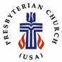

Community Presbyterian Church
505 West Broadway
Plainview, MN 55964
507-534-2298
cpcoffice@hbci.com

Mark Rich
Pastor Administrative Assistant

(c) (c) 507-738-0855
(w) 507-534-2298 (w) 507-534-2298
(w) (w)cpcoffice@hbci.com

Mark Rich
Music Director

507-738-0855
docmusartsmark@gmail.com

Adam Klavetter Tom Ellringer
Groundskeeper Custodian

