COMMUNITY PRESBYTERIAN CHURCH

505 West Broadway

Plainview, MN 55964

Sunday, April 21, 2024

Fourth Sunday in Easter

Welcome to Community Presbyterian Church!

Page 1*Please stand if you like
*Please stand if you like.
Page 2 *Please stand if you like
Sunday, April 21, 2024

Page 1*Please stand if you like
*Please stand if you like.
Page 2 *Please stand if you like

Page 1*Please stand if you like
*Please stand if you like.
Page 2 *Please stand if you like

Fourth Sunday in Easter

Gathering
PRELUDE Joan Lee, Organ

WORDS OF WELCOME

ANNOUNCEMENTS

CALL TO WORSHIP Mark Rich
We come to God, our holy shepherd, as we come to a green meadow.
God prepares a place for us, and we give glory in God’s presence.
How excellent is this dwelling place under the eyes of God’s care.
We turn to God in joy.
Our good shepherd provides for all our needs.

PRAYER OF PRAISE AND ADORATION Mark Rich
Let us pray together:
Providing God, in our journey of faithfulness, we graze in the pastures you lead us to each day. As we move along, our steps may seem aimless, yet you keep watch and never leave. When we are tired, you prepare for us a table. When we are thirsty, your cup of goodness and mercy overflows. When we are lost, you seek us out. And oh, how our hearts leap when you call to us, for we know your voice and feel your love. Dearest God, we are so grateful that your staff of righteousness leads us home. Amen.

OPENING HYMN #280 “Come, O Spirit, Dwell Among Us”

CALL TO CONFESSION Mark Rich
In your holiness, O God, we wait to be filled.
Our faith is tested.
We do not know how your power will ease our hopelessness.
We ask that your Spirit bring us peace of mind and peace of heart.
We pray that you will lift us up out of darkness, and into your everlasting light.
Heal our hopelessness, assure us of your everlasting love given forever and ever.

PRAYER OF CONFESSION Mark Rich
Let us pray together:
Beloved Jesus, Living God, you enter our hearts, even when we are filled with disbelief. You feel our sadness and hurt as we struggle to make sense of our world. You express your love for us by offering yourself, and we are amazed. You ease our doubt, and we are astonished. We give you thanks, saying “My Lord, my God!” Amen.

INDIVIDUAL CONFESSION
ASSURANCE OF PARDON Pastor Amy Kosari
The call to follow Jesus in this new life will be on our hearts.
We are invited now to answer this call.
He rose to bring us along the road of salvation.
He calls to us here, saying, “Come and follow me.”
By the Spirit we are led into a new season, into a new beginning with Christ.
Let us step into joy, the joy of following Jesus. Hallelujah, for the call of Jesus is the power of life everlasting.
GLORY TO GOD #581 “Gloria Patri” “Glory Be to the Father”

SHARING GOD’S LOVE Pastor Amy Kosari

The Word
PRAYER FOR ILLUMINATION Mark Rich
Let us pray together:
Risen One, we confess our silence amid the persecution of others, silence that has often complied with oppression and brought harm. What can we do to eradicate poverty, hunger, and homelessness? Help us to hear your voice above all others, and teach us how to care for our neighbor, feed the hungry, and clothe and care for those in need, for as we do these things unto one another, we do them also unto you.
THE PSALM Mark Rich
Psalm 23
A MUSICAL OFFERING “An Anthem for the Earth” L. Pratt
CPC Choir
THE NEW TESTAMENT LESSON Pastor Amy Kosari
I John 3
MESSAGE “Behold what Matter of Love the Father has Given to Us”
Pastor Amy Kosari

Responding
HYMN #187 “Savior, like a Shepherd Lead Us”
(Verses 1, 2, & 4)

AFFIRMATION OF FAITH (The Apostle’s Creed)
I believe in God, the Father almighty, Maker of heaven and earth;
And in Jesus Christ his only Son, our Lord; who was conceived by the Holy Ghost, born of the Virgin Mary, suffered under Pontius Pilate, was crucified, dead, and buried; he descended into hell; the third day he rose again from the dead; he ascended into heaven, and sitteth on the right hand of God the Father Almighty; from thence he shall come to judge the quick and the dead.
I believe in the Holy Ghost; the holy catholic church; the communion of saints; the forgiveness of sins; the resurrection of the body; and the life everlasting. Amen.

CALL TO PRAYER #291 “Spirit, Spirit of Gentleness” (Refrain, V1, Refrain)

JOYS AND CONCERNS Pastor Amy Kosari

PRAYERS OF THE PEOPLE AND THE LORD’S PRAYER
Our Father, who art in heaven, hallowed be Thy name. Thy kingdom come, Thy will be done, on earth as it is in heaven. Give us this day our daily bread and forgive us our debts as we forgive our debtors. And lead us not into temptation but deliver us from evil, for Thine is the Kingdom and the Power and the Glory forever. Amen.
OFFERINGS OF LOVE AND THANKSGIVING
April Mission of the Month: PEM Summer Migrant Education

DOXOLOGY: #606 “Praise God from Whom All Blessings Flow”

PRAYER OF DEDICATION
Sending
DEPARTING HYMN #754 “Help Us Accept Each Other”
(Verses 1, 2, 3, & 4)
BENEDICTION Pastor Amy Kosari

BENEDICTION SONG #462 “I Love to Tell the Story”
(Verse 1)

POSTLUDE Joan Lee, Organ
GREETERS: Howard Gray & Jason Laske
Financial Information
Mission of the Month for April: PEM Summer Migrant Education Program
General Mission Building Fund Per Capita
04-07-2024 3,250.00 70.00 80.00
04-14-2024 646.00 55.00 80.00
TOTAL 3,896.00 125.00 160.00

(Mission giving total includes Noisy Offering - to Presbytery Missions)
Thank you for your continued support of our church and its ministry

PRAYER LIST

- Prayers for the country of Israel, in their battle against the Hamas.
- Prayers for the resolution of conflicts in the mid-east.
- Prayers for the hostages in Gaza.
- Prayers for Ukraine.
- Prayers for the victims of the earthquake in Taiwan.

This week in the life of Community Presbyterian Church:

Sunday, April 21 Worship at 10:00 a.m.
10:00 a.m. Sunday Morning Worship
11:00 a.m. Coffee Fellowship

Monday, April 22 Office Hours 10:00-2:00

Tuesday, April 23 Office Hours 10:00-2:00

Wednesday, April 24 Office Hours 10:00-2:00
7:00 p.m. Choir rehearsal in sanctuary.

Thursday, April 25 Office Hours 10:00-2:00

Friday, April 26 Office Closed

Saturday, April 27 Office Closed
Progressive Dinner in the evening

Sunday, April 28 Worship at 10:00 a.m.
10:00 a.m. Sunday Morning Worship
11:00 a.m. Coffee Fellowship

ALANON MEETINGS
Alanon Meetings take place weekly on Tuesdays at Plainview Church of Christ from 6:30 to 7:30 p.m. Enter the south door on 2nd Avenue. Alanon is for friends and family members of alcoholics and addiction.

MN ADULT & TEEN CHALLENGE
MN Adult & Teen Challenge will be visiting us on May 5th. This is a very special time of stories of power over addiction with the help of God. They also have prepared choral pieces to sing as a large group. We are going to share a special Potluck Lunch with the group, so please bring a dish to share with everyone on May 5th.

April Birthdays & Anniversaries
Rylee Fenton April 1
Emmaline Polson April 4
Tom & Diane Ellringer April 4
Jeremy & Belinda Strain April 6
Cole Polson April 8
Becky Walkes April 10
Maura & Paige Marshman April 13
Al Kubly April 17
Jordan Alden April 18
Ryan & Tina Fenton April 21
Julie Cranston-Fuentes April 22
Wendy Rollie April 29

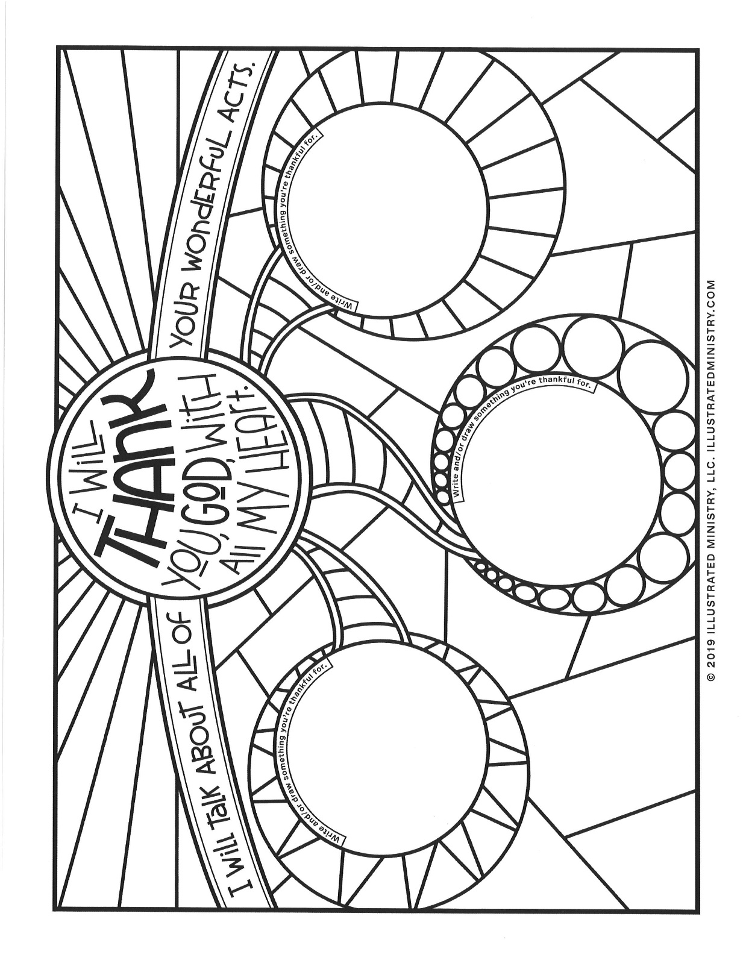

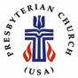

Community Presbyterian Church
505 West Broadway
Plainview, MN 55964
507-534-2298
cpcoffice@hbci.com

Mark Rich
Pastor Administrative Assistant

(c) (c) 507-738-0855
(w) 507-534-2298 (w) 507-534-2298
(w) (w)cpcoffice@hbci.com

Mark Rich
Music Director

507-738-0855
docmusartsmark@gmail.com

Adam Klavetter Tom Ellringer
Groundskeeper Custodian

